Deliverable 3 Instructions

**Overview of the analysis: Explain the purpose of this analysis.**

An analysis was conducted to plan for the retirement of eligible employees at Pewlett Hackard.

The analysis aimed to answer the questions of who would be retiring in the next few years and how many positions will need to be filled.

The analysis also generated a list of employees within the company who can be mentored to fill some of the vacancies that will be coming up.

Postgres and SQL were the tools used to generate the various data sets.

**Results**: Provide a bulleted list with four major points from the two analysis deliverables. Use images as support where needed.

* The results showed the company will have to fill 90,398,vacant positions. There will be a vacancy in all job titles within the company. The breakdown of Retiring titles is attached below.
* 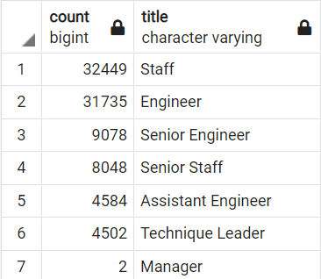
* 1,549 employees are eligible for the mentorship program. Majority of the employees are either senior staff or senior engineers.
* 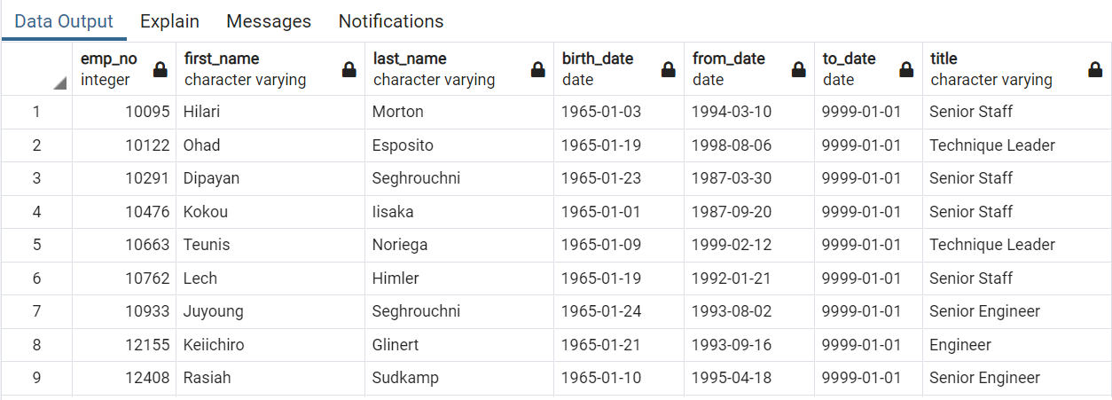
* A majority of the mentorship-eligible employees are either senior staff or engineers.
* There are only 2 managers set to retire.
* Since the number of employees eligible for mentorship is very low, compared to the number of retirement ready employees, the company can decide to also initiate an informal sort of mentorship within each position, that way the employees who are getting ready to retire can train or cross train their colleagues who may not have qualified for the mentorship. This will ensure that vital knowledge and skills are spread throughout the company.

Summary: Provide high-level responses to the following questions, then provide two additional queries or tables that may provide more insight into the upcoming "silver tsunami."

How many roles will need to be filled as the "silver tsunami" begins to make an impact? 90,398 roles will need to be filled as the “silver tsunami" begins to make an impact.

Are there enough qualified, retirement-ready employees in the departments to mentor the next generation of Pewlett Hackard employees? Yes

The table below shows that there are enough qualified retirement ready employees in each department to mentor the next generation of employees. Pewlett Hackard can also collect best practices work place advice from the retirement ready employees and create a library of sorts for generations to come.

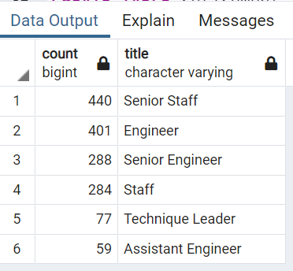

There are 90,398 positions that will need to be filled as the "silver tsunami" begins to make an impact. As only 1,549 employees are eligible for the mentorship program, there are more than enough qualified, retirement-ready employees in the departments to mentor the next generation of Pewlett Hackard employees.

To provide more insight into the upcoming "silver tsunami", it may be helpful to know how many mentorship-eligible employees there are by title (as shown below) to have a better understanding of how to allocate resources when training and filling positions of retirees.